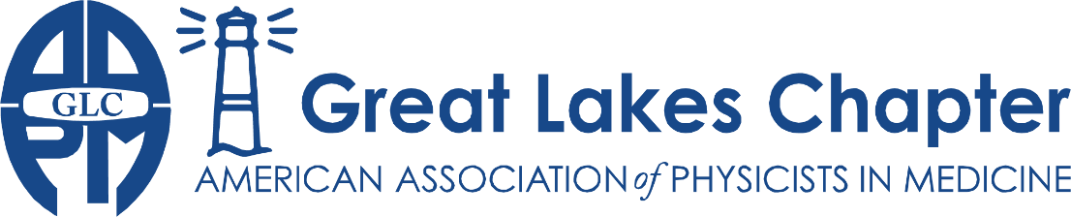
Adrian Nalichowski | Karen Snyder | Donovan Bakalyar | Vrinda Narayana | Brett Miller
President | President-Elect | Treasurer | Secretary | Representative

Meeting Sponsorship Agreement

The Great Lakes Chapter of the AAPM is a professional organization promoting the field of medical physics. We boast over 250 members, many of whom are active participants in the chapter activities. We hold three meetings annually, including one annual meeting. We thank you for agreeing to be a sponsor for this event.

Sponsor Information
Company Name: | ____________________________
Mailing Address: | ____________________________
 | ____________________________
Sponsor Representative: | ____________________________

Meeting |  | Item | Fee
2023 Physics Slam Meeting 03/23/2023 | ☐ | Gold Sponsorship | $1000
 | ☐ | Silver Sponsorship | $500
 | ☐ | Bronze Sponsorship | $300
 | Total Due |  | $
Remit payment to:
Donovan M. Bakalyar, Ph.D.
Diagnostic Radiology
Henry Ford Hospital
2799 West Grand Boulevard
Detroit, Michigan 48202

Payment is due by the date of the sponsored meeting

Thank you for your support!

chapter.aapm.org/glc
glc.aapm@gmail.com

Sponsorship Benefits

Gold
- Sponsor table for promotional materials
- 1 page Sponsor supplied flier will be distributed with electronic announcements.
- One representative will have the opportunity to speak to the group for 5 minutes, as assigned by the meeting planning committee.
- Logo will be shown in large format on all meeting materials including the meeting webpage and handout

Silver
- Sponsor table for promotional materials
- 1 page Sponsor supplied flier will be distributed with electronic announcements
- Logo will be shown in medium format on all meeting materials including the meeting webpage and handout

Bronze
- Sponsor table for promotional materials
- Logo will be shown in small format on all meeting materials including the meeting webpage and handout.

