Radiological and Medical Physics Society of New York, Inc.
Memorial Sloan-Kettering Cancer Center, 1275 York Avenue, New York, NY 10065

2014 Vacirca Young Investigator Symposium

April 22, 2014, 6:00-8:30 PM
Zuckerman Research Laboratories, Room ZRC-105
Memorial Sloan-Kettering Cancer Center
417 E 68th Street, New York, NY 10065

Program:

6:00-6:30 Reception, refreshments will be served

6:30-6:45 Quantitative non-linear compartment modeling of ⁸⁹Zr- and ¹²⁴I-labeled J591 monoclonal antibody kinetics using serial non-invasive positron emission tomography imaging in a pre-clinical human prostate cancer mouse model.
Presented by: Edward K. Fung, MSKCC

6:45-7:00 Separating perfusion and diffusion parameters from diffusion weighted MRI in rectal carcinoma.
Presented by: Kenneth Wengler, MSKCC / St Johns University

7:00-7:15 Accuracy of estimating kinetic rate constants in a shortened dynamic ¹⁸F-FMISO PET acquisition.
Presented by: Milan Grkovski, MSKCC

7:15-7:30 Image Feature Based DRR and Portal Image Registration.
Presented by: Xin Wang, Weill Cornell Medical College

7:30-7:45 Dynamic contrast enhanced (DCE) MRI for response assessment of inoperable lung tumors for patients undergoing SBRT treatment.
Presented by: Michael Liu, MSKCC

7:45-8:00 Spatially accurate ground truth for PET segmentation verification from biopsy specimens extracted under PET/CT guidance.
Presented by: Louise M. Fanchon, MSKCC

8:00-8:15 Phantom Evaluation of Lung Shunt Estimation Methods Conducted Preparatory to ⁹⁰Y Selective Internal Radiotherapy.
Presented by: Alex Zaharakis , Hofstra University

Dinner with presenters and judges will follow

CAMPEP credits have been applied for.

Getting There
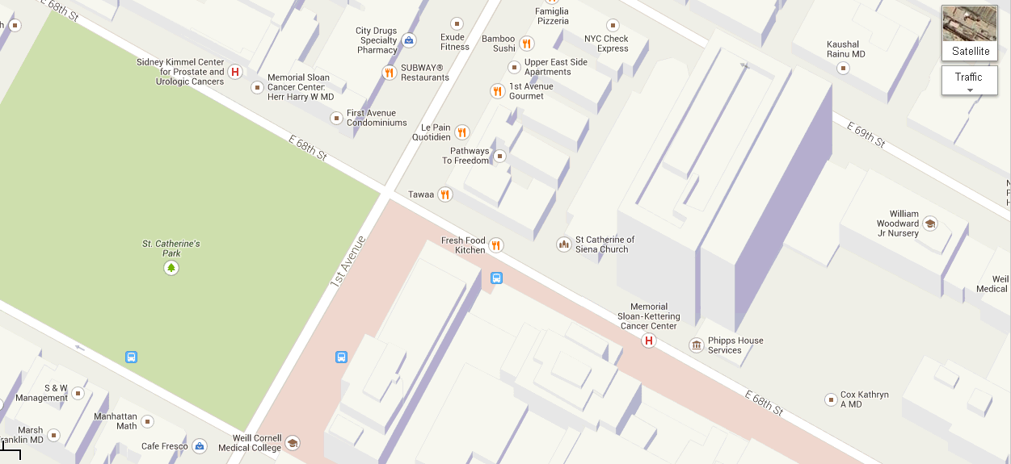
The Zuckerman Building is on north side of 68th Street between 1st and York avenues.

By Subway
Take the #6 train to East 68th Street. Walk four blocks east to First Avenue, or take the M66 bus eastbound to First Avenue.

By Bus
- Take the M31 to the East 67th Street stop, directly in front of Memorial Hospital. (The M31 operates north and south on York Avenue, and across town on 57th Street.)
- Take M15 north bound to First Avenue and 67 Street stop.
- Take M15 south bound to Second Avenue and 68 Street. Walk one block east to First Avenue.

By Car
- Approaching from South of East 68th Street, take the FDR Drive northbound to the 61st Street exit. Make right onto York Avenue and go north to 68th Street.
Approaching from North of East 68th Street, take the FDR Drive southbound to the 71st Street exit. Make left onto York Avenue and go south to 68th Street.

