ANNOUNCING:
RAMPS WEBSITE DESIGN COPMPETITION

RAMPS is actively seeking suggestions for redesign and improvements to our web site. We are seeking innovative and attractive solutions to communications with membership (e.g. announcements, membership application, CAMPEP submissions etc) while expanding and improving information and functionality of our current website (www.chapter.aapm.org/ramps).
As a first step, RAMPS secured a domain name (www.rampsnyc.org), and signed up with a host provider (www.wix.com).

A $500 CASH PRIZE WILL BE AWARDED FOR THE WINNING DESIGN

Terms of the competition:
- The competition is open to all RAMPS members.
- Competitors may team up.
- Competitors/teams should inform RAMPS of their participation by May 16th, via email to: rampsnyc@gmail.com.
- A panel consisting of the RAMPS board members will review and rank the submitted designs.
- The design that gets the highest number of votes (by the RAMPS board) will be the winner.
- A single $500 cash prize will be awarded to the winning individual or team.
- The final design should be transferred to RAMPS (email: rampsnyc@gmail.com) by June 30th, 2014 (see instructions below).
- The winner (Individual/Team) will be announced at the following RAMPS meeting (fall 2014).
- By submitting their design, the individual or team
1. Certifies the submission is their original work, and
2. Gives RAMPS full unrestricted permission to use and modify the designed website or any part thereof.
- All the designs must be created under www.wix.com.
- The mock design does not have to be fully functional but should have (at least) similar content to the current site (www.chapter.aapm.org/ramps).

Here is what you need to do:

1. Sign up for a personal account on www.wix.com

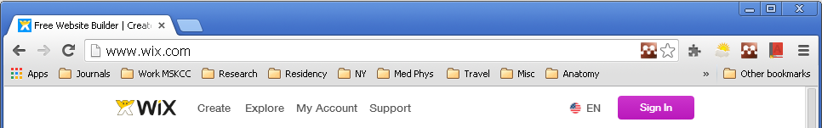
2. Chose the template/design that will best represent the mission of RAMPS
3. Make necessary modifications and be creative.
4. Once finished, transfer your design to RAMPS (rampsnyc@gmail.com) under manage my site as shown below.
