Radiological and Medical Physics Society of New York, Inc.
Memorial Sloan-Kettering Cancer Center, 1275 York Avenue, New York, NY 10065

2014 Spring Symposium

Adaptive Radiation Therapy
Friday May 16th, 2014, 11:15am - 6:00pm
Zuckerman Auditorium, 417 East 68th Street
Memorial Sloan-Kettering Cancer Center, New York, NY

11:15 - 11:45 | Registration
11:45 - 12:00 | Welcome
Gil’ad N. Cohen, MS; President, RAMPS
Department of Medical Physics, Brachytherapy Division, MSKCC
 | Introduction to Adaptive Radiation Therapy
Cesar Della Biancia, PhD; President-Elect, RAMPS
Department of Medical Physics, Treatment Planning Division, MSKCC
12:00 - 12:50 | Introduction to Adaptive Radiation Therapy
 | Nancy Lee, MD
 | Department of Radiation Oncology, Memorial Sloan-Kettering Cancer Center, New York, NY
12:50 - 1:40 | Potential gain in outcomes with Adaptive Radiation Therapy
 | Joseph Deasy, PhD
 | Chair, Department of Medical Physics, Memorial Sloan-Kettering Cancer Center, New York, NY
1:40 - 2:00 | Panel Q&A - Moderator: Kristy Brock, PhD
2:00 - 2:30 | Coffee Break
2:30 - 3:20 | Adaptive Radiotherapy: what to adapt and what to expect?
 | Lei Dong, PhD, FAAPM
 | Director, Department of Medical Physics, Scripps Proton Therapy Center, San Diego, CA
3:20 - 3:35 | VARIAN presentation
Leon Eglezopoulos
Sr. Sales Specialist, Treatment Planning, Varian Medical Systems
3:35 - 3:45 | Panel Q&A - Moderator: Ludvig Paul Muren, PhD
3:45 - 4:05 | Coffee Break
4:05 - 4:55 | Image Registration and Clinical Adaptation in the abdomen
 | Kristy Brock, PhD
 | Associate Professor, Department of Medical Physics, University of Michigan, Ann Arbor, MI
4:55 - 5:45 | Clinical Applications/experiences in Adaptive Radiation Therapy
 | Ludvig Paul Muren, PhD
 | Professor, Department of Medical Physics, Aarhus University Hospital, Aarhus, Denmark
5:45 - 6:00 | Panel Q&A - Moderator: Lei Dong, PhD
6:30 | Reception
 | Lobby of Zuckerman building

Registration

Registration is via PayPal: http://chapter.aapm.org/ramps/Spring_Symp_2014_pay.html
Before May 1st, 2014: RAMPS Members: $50, Non-Members: $75
After May 1st, 2014: RAMPS Members: $60, Non-Members: $85
No Charge for students and residents (letter from advisor attesting status or student ID is required)

Getting There
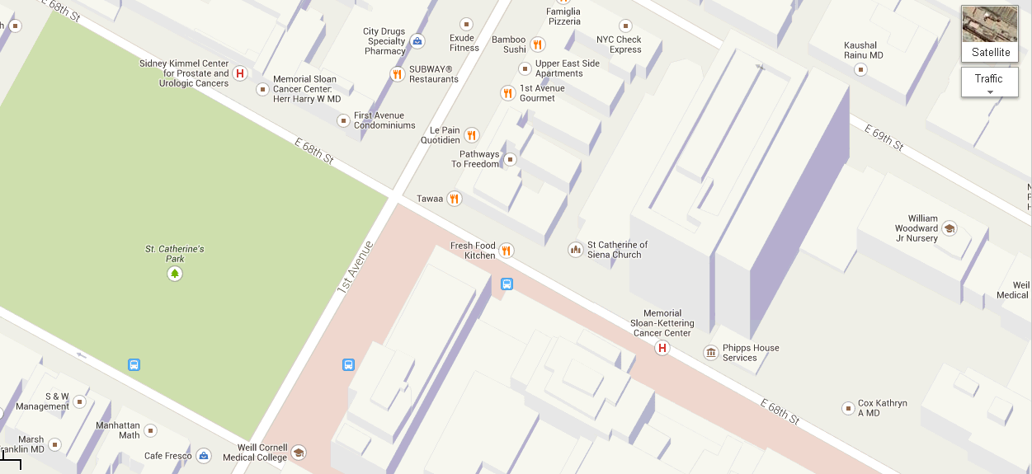
Zuckerman Auditorium is on north side of 68th Street

By Subway
Take the #6 train to East 68th Street. Walk four blocks east to First Avenue, or take the M66 bus eastbound to First Avenue.

By Bus
- Take the M31 to the East 67th Street stop, directly in front of Memorial Hospital. (The M31 operates north and south on York Avenue, and across town on 57th Street.)
- Take M15 north bound to First Avenue and 67 Street stop.
- Take M15 south bound to Second Avenue and 68 Street. Walk one block east to First Avenue.

By Car
- Approaching from South of East 68th Street, take the FDR Drive northbound to the 61st Street exit. Make right onto York Avenue and go north to 68th Street.
- Approaching from North of East 68th Street, take the FDR Drive southbound to the 71st Street exit. Make left onto York Avenue and go south to 68th Street.

