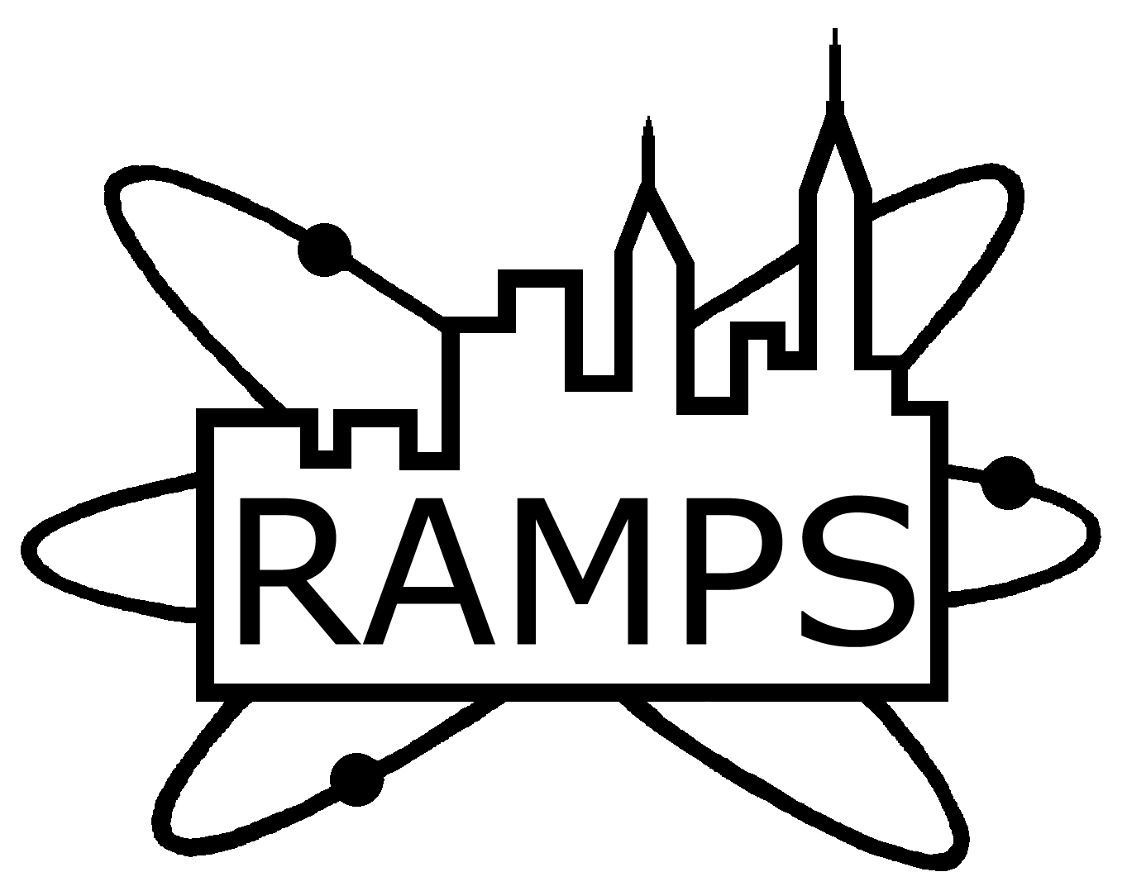
RAMPS
Radiological and Medical Physics Society of New York, Inc.
Memorial Sloan-Kettering Cancer Center, 1275 York Avenue, New York, NY 10065
(212) 639 - 5169

MEETING ANNOUNCEMENT
“AAPM Code of ethics past, present, and future”

SPEAKER:
K. Sunshine Osterman, Ph.D.
Medical Physicist
Department of Radiation Oncology
NYU Langone Medical Center
New York, NY

Memorial Sloan-Kettering Cancer Center – M-107
1275 York Ave, New York, NY

Tuesday, January 19th, 2016
Coffee and Cookies at 6:00 PM
Presentation Commences at 6:30 PM

Educational Objectives:

1. Review the four major components of the Code of Ethics introduced in TG‐109
2. Understand the expanding relationships medical physicists must navigate
3. Outline the AAPM’s standard for professional conduct in clinical, research, educational, and business settings
4. Understand the procedure for lodging complaints for unethical behavior

RAMPS Board Meeting: 5:00-6:00PM, MSKCC: Library S-1132 (Schwartz Building). All members are welcome to attend.

CAMPEP credits: 1.0 MPCEC hours was applied to CAMPEP

Dinner at nearby restaurant @ 8:00PM, $25 pre-paid via PayPal ($30 at the door) for everyone, free for the speaker.

M-107

By Subway
Take the #6 train to East 68th Street. Walk four blocks east to First Avenue, or take the M66 bus eastbound to York Avenue.
By Bus
- Take the M31 to the East 67th Street stop, directly in front of Memorial Hospital. (The M31 operates north and south on York Avenue, and across town on 57th Street.)
- Take M15 north bound to First Avenue and 67 Street stop.
- Take M15 south bound to Second Avenue and 68 Street. Walk two blocks east to York Avenue.
By Car
- Approaching from South of East 68th Street, take the FDR Drive northbound to the 61st Street exit. Make right onto York Avenue.
- Approaching from North of East 68th Street, take the FDR Drive southbound to the 71st Street exit. Make left onto York Avenue.

