RAMPS
Radiological and Medical Physics Society of New York, Inc.
Memorial Sloan-Kettering Cancer Center, 1275 York Avenue, New York, NY 10065
(212) 639 - 5169

MEETING ANNOUNCEMENT

Certitude Attitude: Uncertainties in Risk Estimates for
Radiation-Induced Cancer

SPEAKER:
Lawrence Dauer, PhD
Department of Medical Physics
Memorial Sloan-Kettering Cancer Center
New York, NY

Memorial Sloan-Kettering Cancer Center
Zuckerman Building Seminar Room – ZRC 105
417 E 68th Street (between 1st and York)

Tuesday, February 24, 2015
Coffee and Cookies at 6:00 PM
Presentation Commences at 6:30 PM

Educational Objectives:
- Identify fundamental concepts of statistical uncertainty and epidemiology.
- Recognize sources of uncertainty in radioepidemiological studies.
- Explore the impact of uncertainties in risk assessment (including health effect understanding, exposure, and model uncertainties).
- Address uncertainties in transferring risk quantities from given studies to other exposure conditions or populations of interest.
- Examine uncertainties of selected risk evaluations, including
  - Solid cancer risks after external exposure to 100 mGy.
  - Thyroid cancer after radiation exposure during childhood.
  - Computed Tomography risks.
- Challenge participants to assist on research needs.
- Review conclusions in light of uncertainties.

RAMPS Board Meeting: 5:00-6:00PM, MSKCC: Library S-1134B (Schwartz Building). All members are welcome to attend.

Dinner at nearby restaurant @ 8:00PM, $20 pre-paid via PayPal ($25 at the door) for everyone, free for the speaker.

CAMPEP credits: 1.0 MPCEC hours was applied to CAMPEP

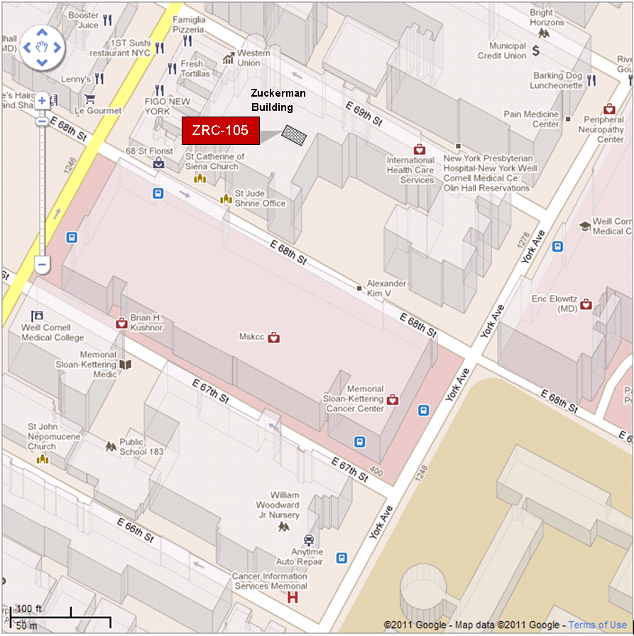

By Subway
Take the #6 train to East 68th Street. Walk four blocks east to First Avenue, or take the M66 bus eastbound to First Avenue.
By Bus
- Take the M31 to the East 67th Street stop, directly in front of Memorial Hospital. (The M31 operates north and south on York Avenue, and across town on 57th Street.)
- Take M15 north bound to First Avenue and 67 Street stop.
- Take M15 south bound to Second Avenue and 68 Street. Walk one block east to First Avenue.
By Car
- Approaching from South of East 68th Street, take the FDR Drive northbound to the 61st Street exit. Make right onto York Avenue and go north to 68th Street.
- Approaching from North of East 68th Street, take the FDR Drive southbound to the 71st Street exit. Make left onto York Avenue and go south to 68th Street.

