RAMPS
Radiological and Medical Physics Society of New York, Inc.
Memorial Sloan-Kettering Cancer Center, 1275 York Avenue, New York, NY 10065
(212) 639 - 5855

MEETING ANNOUNCEMENT

Memorial Sloan-Kettering Cancer Center
Zuckerman Building Auditorium
417 E 68th Street (between 1st and York)

Thursday, February 27, 2014
Coffee and Cookies at 6:00 PM
Presentation Commences at 6:30 PM

The Bowery Series: using skid row alcoholics to test the efficacy of screening and transform prostate cancer, 1951–1966.

SPEAKER:
Robert A. Aronowitz, MD
Department of History and Sociology of Science
University of Pennsylvania
Philadelphia, PA

Educational Objectives:
Learn the detailed history for modern cancer screening practices and treatments; explore the ethics of rapidly diffusing new technologies, especially those that transform the diseases they target.

RAMPS Board Meeting: 5-6PM, MSKCC: S-1132 (Schwartz Building)
-- All members are welcome to attend.

Dinner at nearby restaurant @ 8:00PM, $20 pre-paid via Paypal ($25 at the door) for everyone, free for the speaker.

Note: 1.0 MPCEC hours was applied to CAMPEP
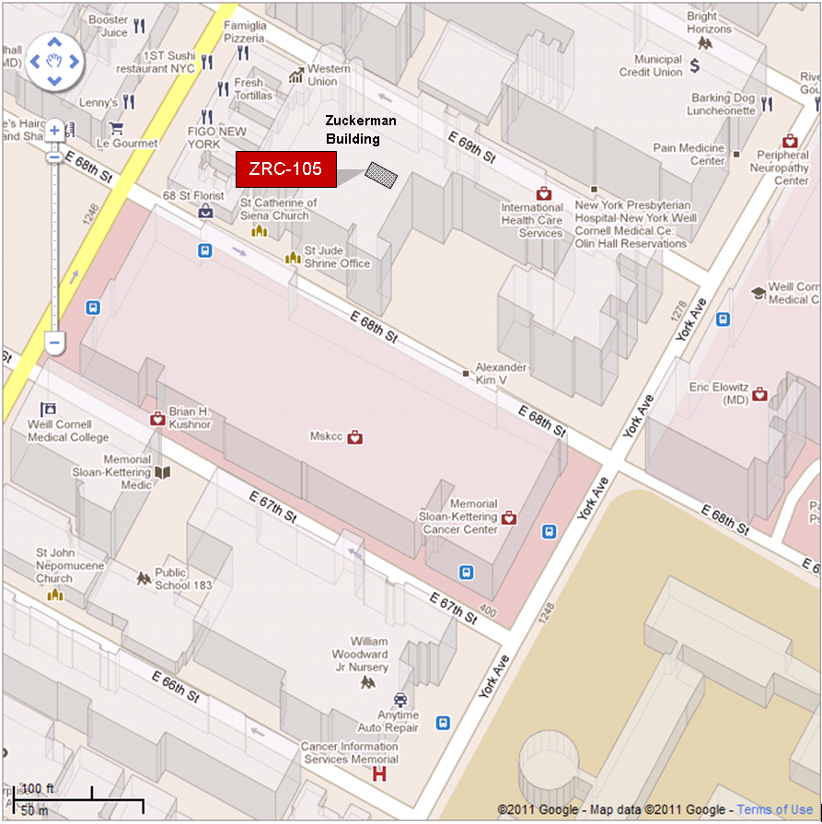

By Subway
Take the #6 train to East 68th Street. Walk four blocks east to First Avenue, or take the M66 bus eastbound to First Avenue.
By Bus
- Take the M31 to the East 67th Street stop, directly in front of Memorial Hospital. (The M31 operates north and south on York Avenue, and across town on 57th Street.)
- Take M15 north bound to First Avenue and 67 Street stop.
- Take M15 south bound to Second Avenue and 68 Street. Walk one block east to First Avenue.
By Car
- Approaching from South of East 68th Street, take the FDR Drive northbound to the 61st Street exit. Make right onto York Avenue and go north to 68th Street.
- Approaching from North of East 68th Street, take the FDR Drive southbound to the 71st Street exit. Make left onto York Avenue and go south to 68th Street.

