RAMPS
Radiological and Medical Physics Society of New York, Inc.
Memorial Sloan-Kettering Cancer Center, 1275 York Avenue, New York, NY 10065
(212) 639 - 5855

MEETING ANNOUNCEMENT

Memorial Sloan-Kettering Cancer Center
Zuckerman Building Seminar Room (ZRC-105)
417 E 68th Street (between 1st and York)

Tuesday, January 28, 2014
Coffee and Cookies at 6:00 PM
Presentation Commences at 6:30 PM

“Medical Events – Errers and Misteaks”

SPEAKER:
Matthew Williamson, MPH, DABHP
Department of Medical Physics
Memorial Sloan-Kettering Cancer Center
New York, New York

Educational Objectives:
- Review the history of medical event reporting requirements
- Review previous and recent medical events
- Define local and federal medical event reporting requirements
- Identify proposed changes to medical event definitions and reporting requirements

RAMPS Board Meeting: 5-6PM, MSKCC: S-1132 (Schwartz Building) -- All members are welcome to attend.

Dinner at nearby restaurant @ 8:30PM, $20 for everyone, free for the speaker.

Note: 1.0 MPCEC hours was applied to CAMPEP
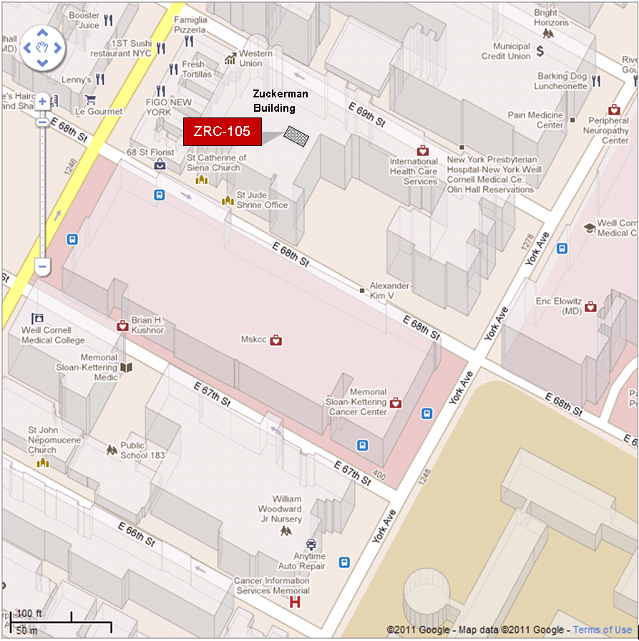

By Subway
Take the #6 train to East 68th Street. Walk four blocks east to First Avenue, or take the M66 bus eastbound to First Avenue.
By Bus
- Take the M31 to the East 67th Street stop, directly in front of Memorial Hospital. (The M31 operates north and south on York Avenue, and across town on 57th Street.)
- Take M15 north bound to First Avenue and 67 Street stop.
- Take M15 south bound to Second Avenue and 68 Street. Walk one block east to First Avenue.
By Car
- Approaching from South of East 68th Street, take the FDR Drive northbound to the 61st Street exit. Make right onto York Avenue and go north to 68th Street.
- Approaching from North of East 68th Street, take the FDR Drive southbound to the 71st Street exit. Make left onto York Avenue and go south to 68th Street.

