RAMPS
Radiological and Medical Physics Society of New York, Inc.
Memorial Sloan-Kettering Cancer Center, 1275 York Avenue, New York, NY 10065
(212) 639 - 5169

ANNUAL BUSINESS MEETING
ANNOUNCEMENT

Thursday, October 8th, 2015

Memorial Sloan-Kettering Cancer Center
Zuckerman Auditorium
417 E 68th Street (between 1st and York)

The Changing Face of AAPM

SPEAKER:
Bruce Curran, MEng, FAAPM, FACMP, FACR
AAPM President-Elect
Associate Professor
Radiation Oncology
Virginia Commonwealth University Medical Center
Richmond, VA

PROGRAM
6:00 pm Reception
6:30 pm President’s and Treasurer’s Reports
7:00 pm Lecture by Bruce Curran, AAPM President-Elect
7:45 pm Questions and Answers
8:15 pm Dinner at nearby restaurant (reservations required)

Educational Objectives:
- Review the AAPM Governance Assessment effort and solicit feedback from RAMPS members
- Discuss recent AAPM Ad Hoc Committee Reports and the changes envisioned by these reports
- Have an open discussion on the recent decision to initiate Author fees for JACMP and explore options

RAMPS Board Meeting: 5:00-6:00PM, MSKCC: Classroom S-1132 (Schwartz Building). All members are welcome to attend.
Registration for dinner is via PayPal (RAMPS website) - Member: $60, Non-Member: $90, Students & Residents: $20.
Note: Registration is for dinner ONLY. Program is free (all are welcome)

CAMPEP credits: 1.0 MPCEC hours was applied to CAMPEP

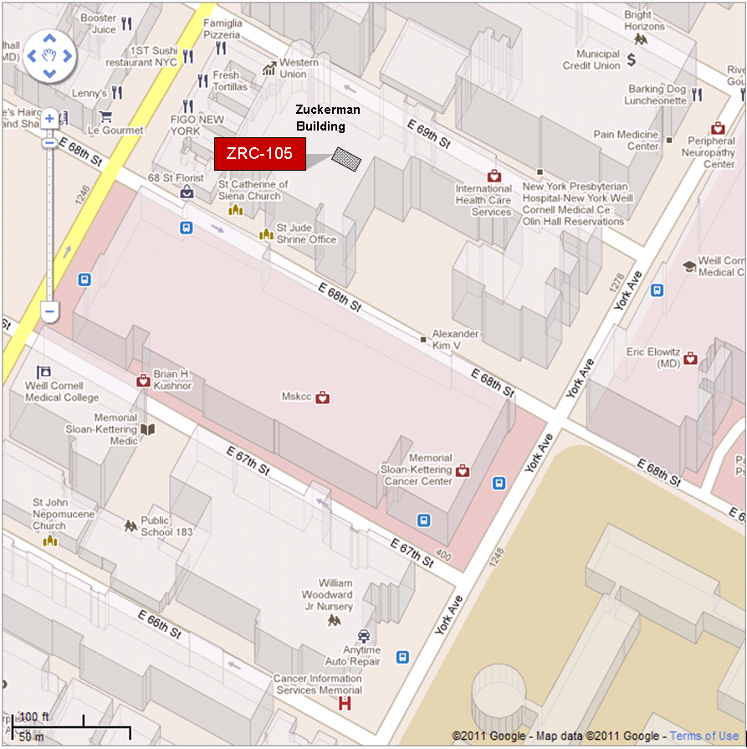

By Subway
Take the #6 train to East 68th Street. Walk four blocks east to First Avenue, or take the M66 bus eastbound to First Avenue.
By Bus
- Take the M31 to the East 67th Street stop, directly in front of Memorial Hospital. (The M31 operates north and south on York Avenue, and across town on 57th Street.)
- Take M15 north bound to First Avenue and 67 Street stop.
- Take M15 south bound to Second Avenue and 68 Street. Walk one block east to First Avenue.
By Car
- Approaching from South of East 68th Street, take the FDR Drive northbound to the 61st Street exit. Make right onto York Avenue and go north to 68th Street.
- Approaching from North of East 68th Street, take the FDR Drive southbound to the 71st Street exit. Make left onto York Avenue and go south to 68th Street.

