
RAMPS
Radiological and Medical Physics Society of New York, Inc.
Memorial Sloan-Kettering Cancer Center, 1275 York Avenue, New York, NY 10065
(212) 639 – 5855

MEETING ANNOUNCEMENT

Memorial Sloan-Kettering Cancer Center
Zuckerman Research Center
417 East 68th Street, New York, NY 10065
Room – ZRC-105

Tuesday, November 20th, 2012
Coffee and Cookies at 6:00 PM
Presentation commences at 6:30 PM

“Clinical and pre-clinical applications of functional MRI”

SPEAKER:
Henning U. Voss, Ph.D.

Associate Professor of Physics in Radiology,
Weill Cornell Medical College, NY, NY

Educational Objectives:
- To learn how functional MRI works
- To learn what one can and cannot do with it
- To learn what clinical applications might be on the horizon

RAMPS Board Meeting: 5-6PM, MSKCC: S-1132. (Schwartz Building) -- All members are welcome to attend.

Note: 1.0 MPCEC was applied to CAMPEP.

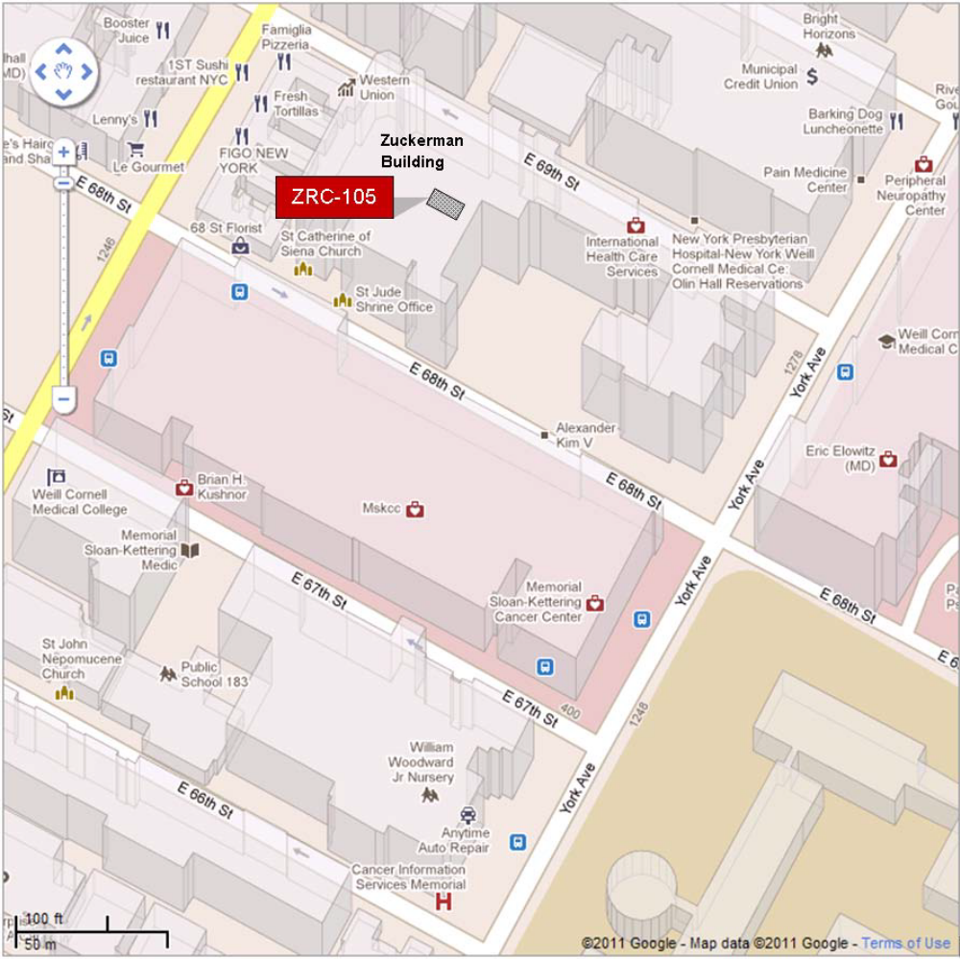

By Subway
Take the #6 train to East 68th Street. Walk four blocks east to First Avenue, or take the M66 bus eastbound to First Avenue.
By Bus
• Take the M31 to the East 67th Street stop, directly in front of Memorial Hospital. (The M31 operates north and south on York Avenue, and across town on 57th Street.)
• Take M15 north bound to First Avenue and 67 Street stop.
• Take M15 south bound to Second Avenue and 68 Street. Walk one block east to First Avenue.

By Car
• Approaching from South of East 68th Street, take the FDR Drive northbound to the 61st Street exit. Make right onto York Avenue and go north to 68th Street.
• Approaching from North of East 68th Street, take the FDR Drive southbound to the 71st Street exit. Make left onto York Avenue and go south to 68th Street.

