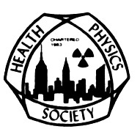
The Greater New York Chapter, Health Physics Society
and
The Radiological and Medical Physics Society of New York
Present:

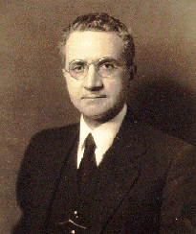

FAILLA MEMORIAL LECTURE

Tuesday, February 26, 2013

Antone L. Brooks, Ph.D.

“The life and times of a Radiation Biologist, from Fear to Respect”

A look at changes in the field of Radiation Biology with special emphasis on internally deposited radioactive materials.

The Griffis Faculty Club

New York-Presbyterian Hospital/Weill Cornell Medical College

521 East 68th Street, New York, NY 10065 (Directions attached)

Board Meeting 5:00- 6:00 PM
Cocktail Hour 6:00 – 7:00 pm
Dinner and Presentation 7:00- 9:00PM

To register please call or email
Maureen McDonnell 212-639-8300, rampsnyc@gmail.com
Register before February 15th: $50 RAMPS members, $75 non-members, after February 15th: $80 all.

Note: 1.5 MPCEC hours were applied for to CAMPEP and to ABHP.

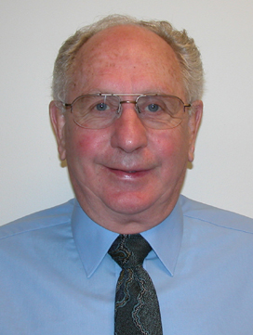

Antone L. Brooks, Ph.D.
http://www.tricity.wsu.edu/faculty/brooks/Brooks_A.html
Institution and Location, Degree, Year, Field of Study:
- University of Utah, Salt Lake City, Utah B.S. 1961 Experimental Biology
- University of Utah, Salt Lake City, Utah M.S. 1963 Radiation Ecology
- Cornell University, Ithaca, New York Ph.D. 1967 Physical Biology

Dr. Brooks retired in 2008 from the Washington State University Tri-cities as a Professor in the Environmental Science Department. His career included positions as Laboratory Senior Scientist and Section Manager at Battelle, Pacific Northwest National Laboratory; Manager of the Cellular and Molecular Toxicology Group at Lovelace Inhalation Toxicology Research Institute, Albuquerque; and Technical Representative in Washington D.C. for the U.S. Department of Energy, Office of Health and Environmental Research. He is a member of the Health Physics Society, the Mutation Research Society, and the Radiation Research Society.

Dr. Brooks’ research interests include cytogenetics, radiation-induced cancer, radiation risk, and public outreach on radiation effects. The focus of his research has been understanding the biological changes induced by low doses of ionizing radiation. Dr. Brooks served as the Principal Investigator for the project “Optimizing the Scientific Regulatory and Societal Impact of the DOE Low-Dose Research Program.” This includes radiation from both external radiation sources and from internally-deposited radioactive materials. The use of biomarkers for exposure, dose, susceptibility and disease have been a major research effort directed toward making it possible to better estimate radiation risk using short term biological endpoints. Dr. Brooks has authored or co-authored over 170 publications.

Dr. Brooks was first elected to NCRP in 1979 and served as a member for 30 years becoming a
Distinguished Emeritus Member in 2009. Dr. Brooks served on the Board of Directors and was Scientific Vice President for PAC 1, Basic Criteria, Epidemiology, Radiobiology and Risk from 2005 to 2008. He chaired Scientific Committees (SC) 1-3, 57-10, 57-11; co-chaired both SC 1-13 and 57-10; and was a member of SC 45 and SC 83. Dr. Brooks chaired the Annual Meeting Program Committee in 2008 and served as a member in 2002.

Directions and Parking for The Griffis Faculty Club:

By Subway

Take the #6 train to East 68th Street. Walk four blocks east to York Avenue, or take the M66 bus eastbound to York Avenue.

By Bus

Take the M31 to the East 69th Street stop, directly in front of Weill Cornell Medical College. (The M31 operates north and south on York Avenue, and across town on 57th Street.)

Cross town buses M30, M66, and M72 allow you to transfer to the M31 at York Avenue.

By Car

Approaching from South of East 68th Street, take the FDR Drive northbound to the 61st Street exit. Make right onto York Avenue and go north to 68th Street.

Approaching from North of East 68th Street, take the FDR Drive southbound to the 71st Street exit. Make left onto York Avenue and go south to 68th Street.

Parking

Parking is available 24 hours a day at nearby facilities at the following parking garages:

Greenberg
525 E. 68th Street
(between York Ave. & East River)
Tel: (212) 746-2015

Helmsley
507 E. 70th Street
(between York Ave.& East River)
Tel: (212) 746-1974

Payson
426 E. 71st Street
(between First Ave. & York Ave.)
Tel: (212) 746-1977

Phipps House
1285 York Avenue
(between E. 68th St. & E. 69th St.)
Tel: (212) 746-1979

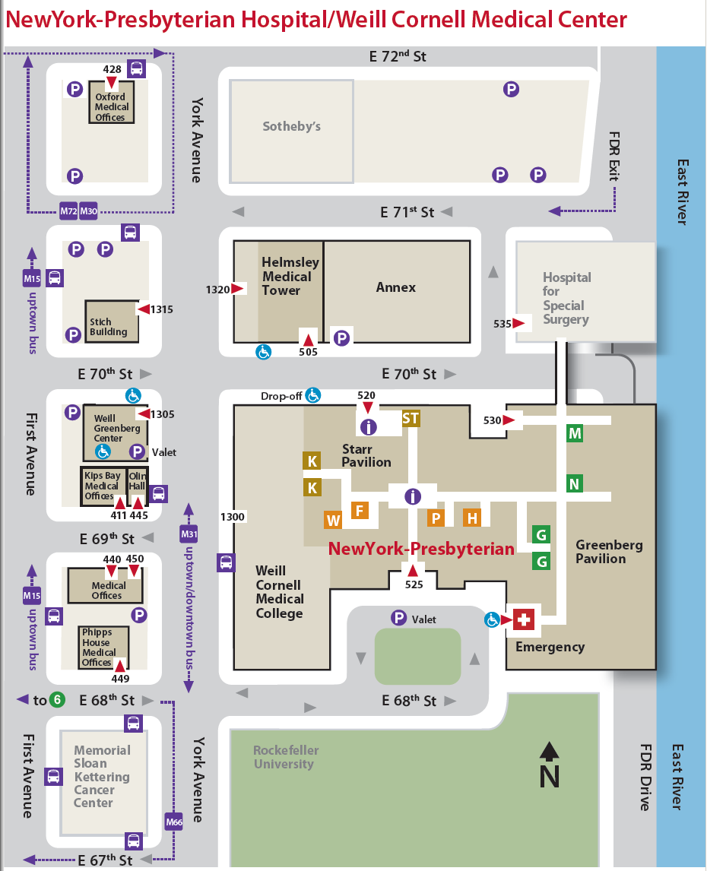
Griffis Faculty Club

