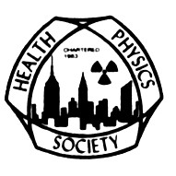 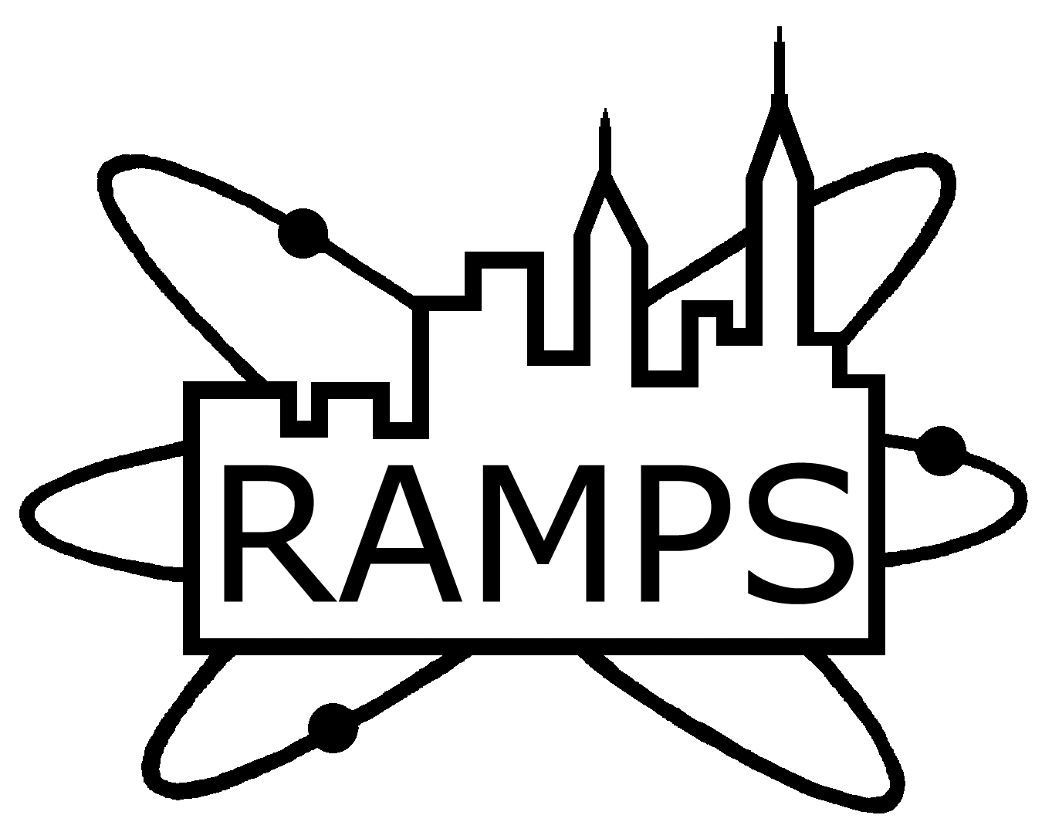

The Greater New York Chapter, Health Physics Society

and

The Radiological and Medical Physics Society of New York

Present:

**The Golden Jubilee of**

### FAILLA MEMORIAL LECTURE

**will be held on Tuesday, January 24, 2012**

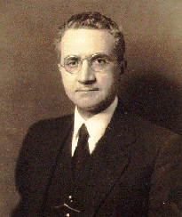

**C. Clifton Ling, Ph.D.**

**“Failla and Colleagues: Geniuses and Serendipity”**

**Educational Objective: To understand aspects of the early development of brachytherapy, external beam radiotherapy, radiation protection, radiobiology and nuclear imaging.**

## [**The Griffis Faculty Club**](http://www.griffisfacultyclub.com/)

## New York-Presbyterian Hospital/Weill Cornell Medical College

## 525 East 68th Street, New York, NY 10065 (Directions attached)

Board Meeting 5:00- 6:00 PM

Cocktail Hour 6:00 – 7:00 pm

Dinner and Presentation 7:00- 9:00PM

On-line registration for this event will be open between December 13, 2011 and January 15, 2012.

The cost for members and their guest (up to one) is $60 per person and for non-members is $120.

PayPal Link to register: <http://chapter.aapm.org/ramps/Failla_mem_lect_2012_pay.html>

1 MPCEC hour was applied to CAMPEP.



**C. Clifton Ling, Ph.D. – Failla Memorial Lecturer (2011)**

Dr. C. Clifton Ling received his Ph.D. in Nuclear Physics from the University of Washington, Seattle, in 1971 and his postdoctoral training in radiation biophysics and medical physics at Memorial Sloan-Kettering Cancer Center (MSKCC). He was a faculty member at the Massachusetts General Hospital and Harvard Medical School, George Washington University Medical Center, and University of California, San Francisco. In 1989, Dr. Ling became the Enid A. Haupt Professor and Chairman of the Department of Medical Physics, MSKCC, and Professor of Radiology (Physics), Weill Medical College of Cornell University. He stepped down as Chair in 2007, and is presently working at MSKCC and Varian Medical Systems.

During his successful career, Dr. Ling has made significant contributions to medical physics research including the fundamentals of cancer radiation biology to optimized radiation treatment planning and delivery, and more recently biological and molecular imaging as applied to cancer management. He has studied the oxygen effect, dose rate effects and the repair of sublethal damage, hypoxic cell radiosensitization, radiation induced carcinogenesis and apoptosis, and the effects of oncogenes on radiosensitivity. Dr. Ling also contributed significantly to brachytherapy dosimetry and the development and widespread use of 3DCRT and IMRT. Dr. Ling has been the principal investigator on numerous grants from the National Institutes of Health, Department of Energy, and American Cancer Society. He has published over 250 peer-reviewed papers and 30 chapters in books and proceedings. He was on grant review panels of both the U.S. and Canadian National Cancer Institutes. He served on the editorial boards of Medical Physics, International Journal of Radiation Oncology/Biology/Physics, Radiotherapy and Oncology, Seminars in Radiation Oncology, Radiation Research, and Radiographics. Over the years, Dr. Ling has been actively involved in educational as well as professional activities. He has trained many students and physicists. He served on the committees of many professional societies. For example, he served on the AAPM Board of Directors and chaired the Scientific Program Committee and Science Council. He also served as chair of the ASTRO Radiation Physics Committee, and Councilor in Physics in Radiation Research Society.

Dr. Ling has received numerous honors and awards, including ASTRO Gold Medal Award, AAPM William D. Coolidge Award, Honorary Member of ESTRO, Evan and Marion Helfaer Distinguished Lectureship of the Medical College of Wisconsin Cancer Center, Ray Bush Visiting Professor of Princess Margaret Hospital and Ontario Cancer Institute, Suntharalingam Lecturer of Thomas Jefferson University, Speaker of the Royal College of Physicians and Surgeons of Canada, Ira Spiro Visiting Professor of Harvard Medical School, Franz Buschke Lecturer of University of California, San Francisco, and James Purdy Lecturer of Washington University, St. Louis. He was a keynote speaker at the UK Radiation Oncology Society and Japan Radiological Society annual meetings in 2003. He received the Distinguished Achievement and Contribution Award from the Chinese Society of Radiation Oncology, Republic of China, in 2007, and the Hall of Fame recognition from the North America Chinese Medical Physicist Association in 2008.

**Directions and Parking for** [**The Griffis Faculty Club**](http://www.griffisfacultyclub.com/)**:**

**By Subway**

Take the #6 train to East 68th Street. Walk four blocks east to York Avenue, or take the M66 bus eastbound to York Avenue.

**By Bus**

Take the M31 to the East 69th Street stop, directly in front of Weill Cornell Medical College. (The M31 operates north and south on York Avenue, and across town on 57th Street.)

Cross town buses M30, M66, and M72 allow you to transfer to the M31 at York Avenue.

**By Car**

Approaching from South of East 68th Street, take the FDR Drive northbound to the 61st Street exit. Make right onto York Avenue and go north to 68th Street.

Approaching from North of East 68th Street, take the FDR Drive southbound to the 71st Street exit. Make left onto York Avenue and go south to 68th Street.

**Parking**

Parking is available 24 hours a day at nearby facilities at the following parking garages:

Greenberg

525 E. 68th Street

(between York Ave. & East River)

Tel: (212) 746-2015

Helmsley

507 E. 70th Street

(between York Ave.& East River)

Tel: (212) 746-1974

Payson

426 E. 71st Street

(between First Ave. & York Ave.)

Tel: (212) 746-1977

Phipps House

1285 York Avenue

(between E. 68th St. & E. 69th St.)

Tel: (212) 746-1979

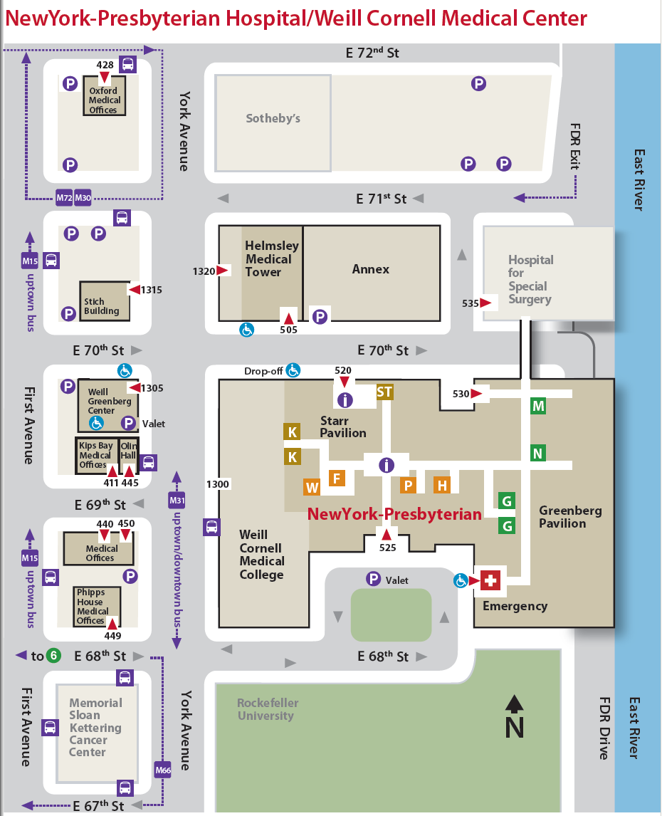

**Griffis Faculty Club**