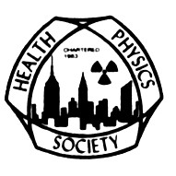
The Radiological and Medical Physics Society of New York
and
The Greater New York Chapter, Health Physics Society
Present:

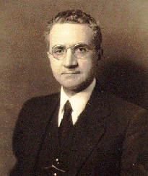

FAILLA MEMORIAL LECTURE

Tuesday, March 25, 2014

David W. O. Rogers, Ph.D.

“Monte Carlo simulation of radiation transport: from bombs to the clinic”

The Griffis Faculty Club

New York-Presbyterian Hospital/Weill Cornell Medical College

521 East 68th Street, New York, NY 10065 (Directions attached)

Board Meeting 5:00- 6:00 PM
Cocktail Hour 6:00 – 7:00 pm
Dinner and Presentation 7:00- 9:00PM

To register please click here for the PayPal link
http://chapter.aapm.org/ramps/Failla_Mem_Lect_2014_pay.html

Register by March 20th: $55 RAMPS/GNYCHPS members, $75 non-members, after March 20th: $90 all.

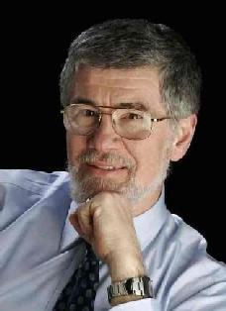

David W. O. Rogers, PhD
Canada Research Chair in Medical Physics
Physics Department, Carleton University

BSc (1968), University of Toronto
MSc(1969), University of Toronto
PhD (1972), University of Toronto

http://physics.carleton.ca/people/faculty-canada-research-chairs/david-w-o-rogers

Research Summary
Development of Monte Carlo codes for radiotherapy, in particular the BEAMnrc code which simulates radiotherapy accelerators and 60Co units, the DOSXYZnrc code which calculates the dose in a patient based on CT information and the BrachyDose code which models brachytherapy applied in for prostate, breast and eye-plaque treatments.
Development of general purpose codes for simulating transport of electrons and photons in arbitrary geometries. The EGSnrc code, an improved version of the EGS4 code, was released in May 2000 and is updated annually in collaboration with NRC. Careful benchmarks against measured data are carried out.
Application of Monte Carlo techniques to calculate correction factors required for primary radiation standards and dosimetry protocols.
Studies of fundamental physics related to dosimeters such as ion chambers and diode dosimeters. Recent experimental and computational work showed that the standard pressure-temperature correction does not work for x-ray beam dosimetry.
Simulation studies of off-focal radiation from x-ray tubes and improved efficiency of x-ray tube simulations.
Spearheaded the development of the AAPM's TG-51 protocol for external beam radiotherapy reference dosimetry.

Directions and Parking for The Griffis Faculty Club:

By Subway

Take the #6 train to East 68th Street. Walk four blocks east to York Avenue, or take the M66 bus eastbound to York Avenue.

By Bus

Take the M31 to the East 69th Street stop, directly in front of Weill Cornell Medical College. (The M31 operates north and south on York Avenue, and across town on 57th Street.)

Cross town buses M30, M66, and M72 allow you to transfer to the M31 at York Avenue.

By Car

Approaching from South of East 68th Street, take the FDR Drive northbound to the 61st Street exit. Make right onto York Avenue and go north to 68th Street.

Approaching from North of East 68th Street, take the FDR Drive southbound to the 71st Street exit. Make left onto York Avenue and go south to 68th Street.

Parking

Parking is available 24 hours a day at nearby facilities at the following parking garages:

Greenberg
525 E. 68th Street
(between York Ave. & East River)
Tel: (212) 746-2015

Helmsley
507 E. 70th Street
(between York Ave.& East River)
Tel: (212) 746-1974

Payson
426 E. 71st Street
(between First Ave. & York Ave.)
Tel: (212) 746-1977

Phipps House
1285 York Avenue
(between E. 68th St. & E. 69th St.)
Tel: (212) 746-1979

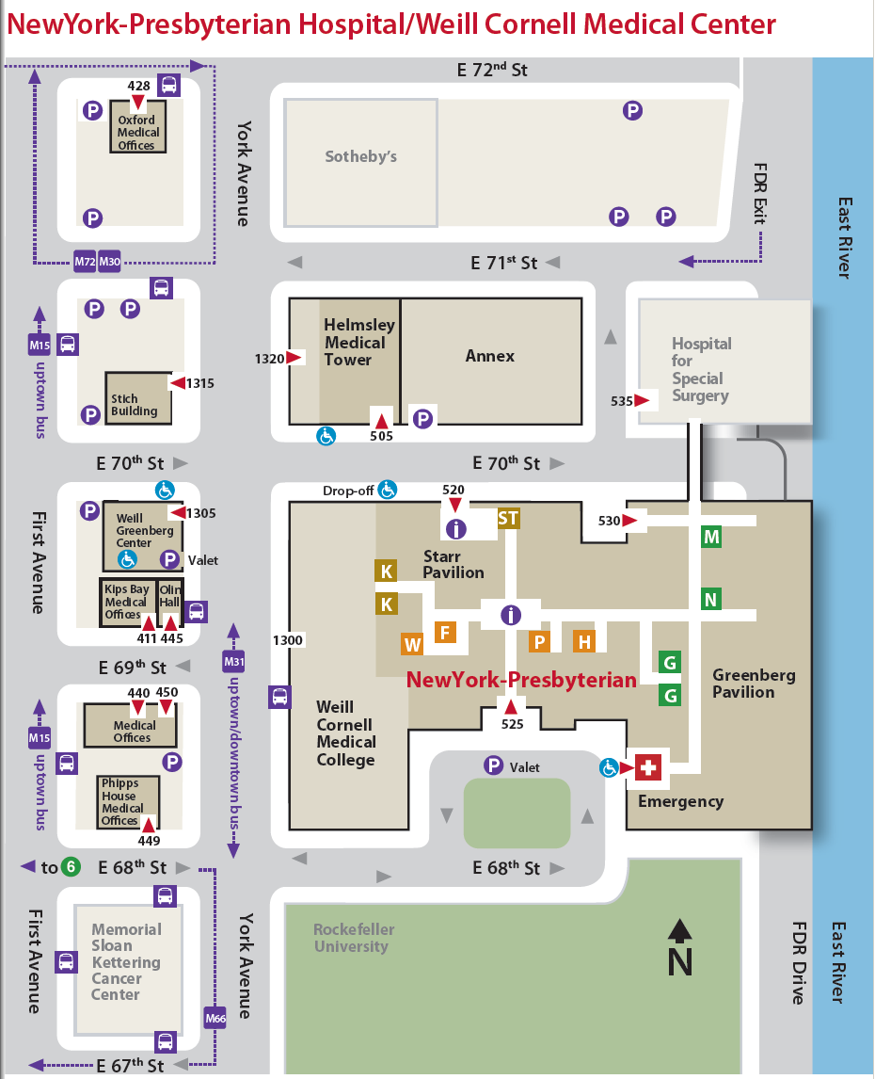
Griffis Faculty Club

