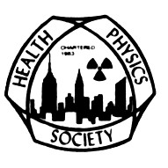
The Radiological and Medical Physics Society of New York
and
The Greater New York Chapter, Health Physics Society
Present:

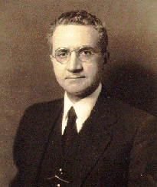

FAILLA MEMORIAL LECTURE

Tuesday, January 20, 2015

Isabel M. Fisenne, PhD, FHPS

“A Trip Through the Periodic Table”

The Griffis Faculty Club

New York-Presbyterian Hospital/Weill Cornell Medical College

521 East 68th Street, New York, NY 10065 (Directions attached)

Board Meeting 5:00- 6:00 PM (Room Whitney 118)
Cocktail Hour 5:30 – 7:30 pm
Dinner and Presentation 7:30- 9:30PM

Registration is via PayPal. Please click here to register.

Register by January 16th: $55 RAMPS members, $75 non-members, after January 16th: $90 all.

ISABEL M. FISENNE

Dr. Isabel M. Fisenne received her B.A. in Chemistry from New York University Washington Square College, her M.S. in Environmental Science from New York University Graduate School of Engineering and Science, Her Ph.D. in Environmental Science from New York University Institute of Environmental Medicine, and her APC in Management from New York University Graduate School of Business Administration.

She has spent her entire career in government service, first with the U.S. Atomic Energy Commission Health and Safety Laboratory, then its descendants, to the present U.S. Department of Homeland Security’s Environmental Measurements Laboratory.

Dr. Fisenne is an internationally recognized expert in the radiochemistry and radiometric measurements of naturally-occurring radionuclides in man and the environment. She has performed special radiochemical analyses for DoD (bioassay on Desert Storm veterans for depleted uranium) and ²¹⁰Po analyses for Health Canada.

Dr. Fisenne has published over 50 peer review journals articles, 40 scientific reports and presented over 50 papers at scientific meetings. She is the author of the chapter entitled “ Uranium” in "Handbook on Metals in Clinical and Analytical Chemistry", a chapter on “ The Risk from Inhalation to Long-lived Radionuclides Uranium, Thorium and Fallout Plutonium in the Atmosphere” in “Aerosols Handbook: Measurement, Dosimetry , and Health Effects”. She prepared and delivered an invited tutorial lecture entitled "Long-Lived Radionuclides in the Environment, in Food and in Human Beings" at the Fifth International Symposium on the Natural Radiation Environment (NRE) and prepared a paper for NRE VII entitled “Stratospheric Radon Measurements in Three North American Locations”. She prepared a section on naturally-occurring radionuclides for the United Nations Scientific Committee on the Effects of Atomic Radiation Report 2000.

Her committee work included the National Council on Radiation Protection and Measurements, which produced NCRP Report 97, "Measurement of Radon and Radon Daughters in Air" and a Health Physics Society committee which produced a report on "Upgrading Environmental Radiation Data". At present she is a consultant to the US Transuranium and Uranium Registries, a member of ASTM Committee C26 on the Nuclear Fuel Cycle.

At the invitation of Dr. Bernard Rostker, DoD Special Assistant for Gulf War Illnesses, Dr. Fisenne peer reviewed the DoD document entitled Environmental Exposure Report, Depleted Uranium in the Gulf.

She served as EML liaison to the DOE Office of Technology Development, Laboratory Management Division. She participates in the review of proposals for the National Nuclear Security Administration.

Dr. Fisenne is an Adjunct Associate Professor at New York University. She has received achievement awards from ASTM and her peers at the Bioassay, Environmental and Analytical Chemistry Conference. She was elected a Fellow of the Health Physics Society.

Directions and Parking for The Griffis Faculty Club:

By Subway

Take the #6 train to East 68th Street. Walk four blocks east to York Avenue, or take the M66 bus eastbound to York Avenue.

By Bus

Take the M31 to the East 69th Street stop, directly in front of Weill Cornell Medical College. (The M31 operates north and south on York Avenue, and across town on 57th Street.)

Cross town buses M30, M66, and M72 allow you to transfer to the M31 at York Avenue.

By Car

Approaching from South of East 68th Street, take the FDR Drive northbound to the 61st Street exit. Make right onto York Avenue and go north to 68th Street.

Approaching from North of East 68th Street, take the FDR Drive southbound to the 71st Street exit. Make left onto York Avenue and go south to 68th Street.

Parking

Parking is available 24 hours a day at nearby facilities at the following parking garages:

Greenberg
525 E. 68th Street
(between York Ave. & East River)
Tel: (212) 746-2015

Helmsley
507 E. 70th Street
(between York Ave.& East River)
Tel: (212) 746-1974

Payson
426 E. 71st Street
(between First Ave. & York Ave.)
Tel: (212) 746-1977

Phipps House
1285 York Avenue
(between E. 68th St. & E. 69th St.)
Tel: (212) 746-1979

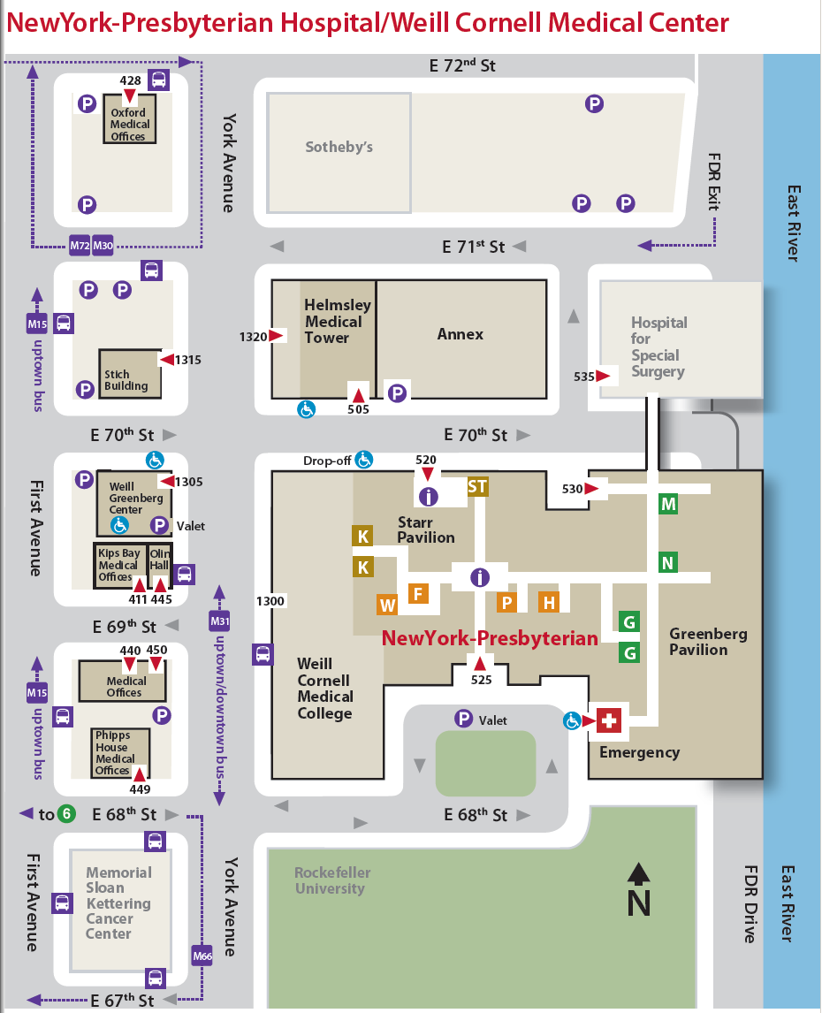
Griffis Faculty Club

