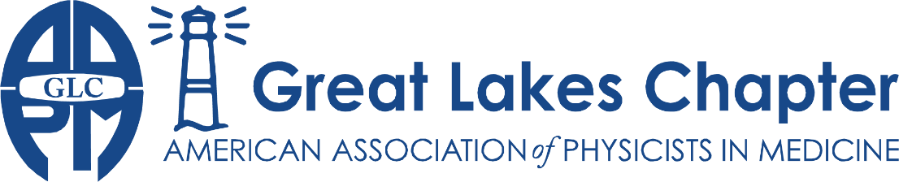
Adrian Nalichowski | Karen Snyder | Donovan Bakalyar | Vrinda Narayana | Brett Miller
President | President-Elect | Treasurer | Secretary | Representative

2022 Annual Meeting Sponsorship Agreement

The Great Lakes Chapter of the AAPM is a professional organization promoting the field of medical physics. We boast over 250 members, many of whom are active participants in the chapter activities. We hold three meetings annually, including the historic Great Debate, a Spring Clinical and a Fall Scientific Meeting. This year we are hosting the GLC-AAPM 2022 Annual Meeting (in person) on 12/8/2022. We thank you for agreeing to be a sponsor for this event.

Sponsor Information
Company Name: | ____________________________
Mailing Address: | ____________________________
 | ____________________________
Sponsor Representative: | ____________________________

Meeting |  | Item | Fee
2022 Annual Meeting 12/8/2022 | ☐ | Gold Sponsorship | $1000
 | ☐ | Silver Sponsorship | $500
 | ☐ | Bronze Sponsorship | $300
 | Total Due |  | $
Remit payment to:
Donovan M. Bakalyar, Ph.D.
Diagnostic Radiology
Henry Ford Hospital
2799 West Grand Boulevard
Detroit, Michigan 48202

Payment is due by the date of the sponsored meeting

Thank you for your support!

chapter.aapm.org/glc
glc.aapm@gmail.com

